Monster PI Team:

Morphology Teaching Resources
This document contains eleven lesson plan ideas and ways to incorporate morphological principles into your vocabulary and reading instruction. They are organized according to the four skills on our assessment. We hope you find them useful!
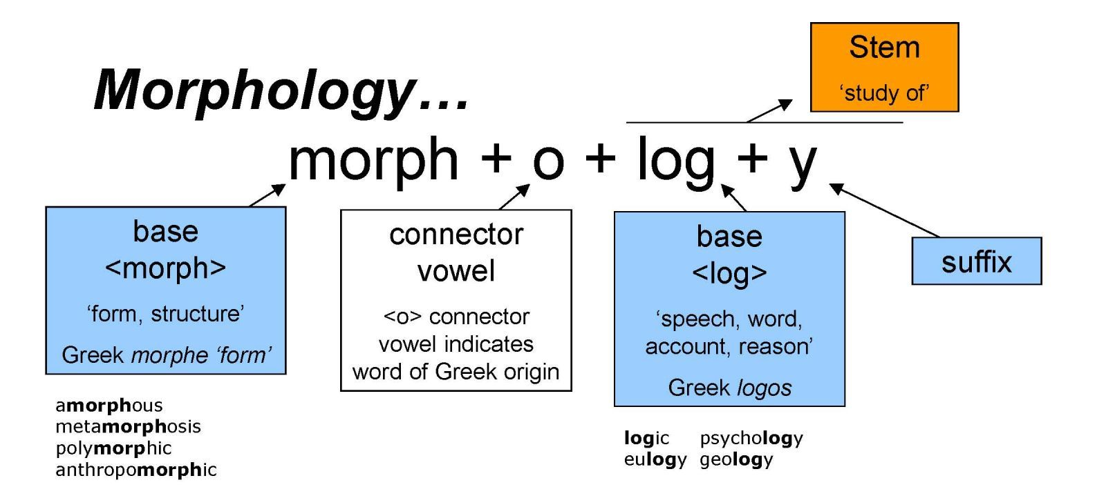
A monster from the iPad assessment
Skill 1: Students can identify units of meaning

Lesson idea 1: Flip-a-Chip
Purpose: Use poker chops with roots, prefixes and suffixes to mix and match to create new words.
Length: 1-2 45 minute lessons
Grade: 6-8
Best part: interactive and hands-on

URL: http://www.readwritethink.org/classroom-resources/lesson-plans/flip-chip-examining-affixes-253.html?tab=4#tabs

Lesson idea 2: You can’t spell prefix without a prefix
Purpose: define prefix, explain their purpose in altering meaning of words, develop word knowledge
Length: variable – there are several games and extensions provided
Grade: 6-8
Best part: lots of options, uses games and competition, applications in writing

URL: http://www.readwritethink.org/classroom-resources/lesson-plans/spell-word-prefix-without-399.htmlhttp://www.readwritethink.org/classroom-resources/lesson-plans/spell-word-prefix-without-399.html?tab=4#tabs

Lesson idea 3: BrainPop: Playing with Prefixes and Suffixes
Purpose: Understand the function of root words, prefixes, and suffixes; create new words by adding prefixes and suffixes to root words.
Length: 1 lesson plan
Grade: Lower middle
Requirements: access to the internet
Best Part: multimedia, includes short video

URL: https://educators.brainpop.com/lesson-plan/prefixes-suffixes-and-root-words/

Lesson Idea 4: Building Words
Purpose: use cut-outs of word parts to build correct and “incorrect” words – reflect on patterns of meaning
Grade: varied
Link: https://teachling.wwu.edu/lessonplans/building-words-exploring-patterns-prefixes-suffixes-roots-parts-speech

Two other quick ideas for activities involving Skill 1: identifying morphemes
- Affixes game: http://www.teach-nology.com/teachers/lesson_plans/language_arts/spell/912root.html
- Morpheme match-ups (with handout); http://www.readwritethink.org/classroom-resources/lesson-plans/rooting-meaning-morpheme-match-880.html

Skill 2: Students can use suffixes for syntactic information
Lesson Idea 1: Cloze Passages Mad Libs!
Purpose: Use context clues and grammar to adjust vocabulary words to fit the sentence
Length: 10-15 minutes, works best with vocabulary that you are using in class
Grade: varied
Best Part: It can be adjusted for your class and built into a regular routine.

Directions:
Write sentences that are missing a target vocabulary word, but provide the root word as a clue. This can be done as a worksheet, in pairs, or as a full class with oral reading component that makes it fun. Using content words embedded in your course makes it especially meaningful and efficient way to both teach your vocabulary words and use morphological principles. While reviewing the correct answer, help students identify how they knew how to change the affix. This helps them begin to connect word parts to syntax.

Examples:
1. There are millions of [create] ___________ in the sea created some of the most diverse ecosystems in the world. [Answer: creatures]
Clue: there are millions of them, so it’s probably a noun, a thing that there could be millions of. Create is a verb, sound like an action, so we know it can’t stay like that. Also – “of” suggests that a noun will come afterwards—an object for that preposition.
2. The [ambition] __________ politician knew that she wanted to president someday. [Answer: ambitious]
Clue: politician is a person (or a noun) and this word has to be describing that person. Therefore, it’s an adjective. What are some endings for adjectives? Ive, ous, etc. Joyous, fabulous, disastrous.
Here is another worksheet with similar activities with random words
http://www.teach-nology.com/worksheets/language_arts/prefix/suffix1.pdf

**It is also fun and amusing to read the wrong versions of these sentences—students’ ears are often tuned to proper syntax. Millions of create in the sea sounds immediately wrong to them!
**Enrichment idea: Have students create the sentences using their own vocabulary words or by pulling morphologically complex words embedded in sentences from the text you’re reading. Encourage students to get creative!

Lesson idea 2: Roots into sentences
Purpose: Help students recognize the syntactic roles of different words with like roots.
Length: can vary—could be a bellringer or a whole lesson
Choose a vocabulary word you’re working with—say, industrial. Then, come up with several different variants of the word with different parts of speech: industrial (adjective), industrialize (verb), industrialization (noun), industry (noun), industrially (adverb). Then, ask students to build phrases or sentences around each of the variants.
- Group idea: assign each small group a different word, then have those groups present their sentences to the class.
- Enrichment idea: ask the students to provide the morphological variants

Skill 3: Students an use morphology for meaning

Lesson Idea 1: Go Fish
Purpose: Helps students build knowledge of word families/groups
Length: 20 minutes, works best with vocabulary that you are using in class
Grade: 6-8
Best Part: It’s a game.

Directions:
1. Prepare the decks (have a student volunteer help you with this if you can) You’ll need 1 deck for each group playing. There is an “answer” key with all words within their family.
2. Put students in groups of 2-4.
3. Explain the rules for Go Fish –
- Today we’re going to play a classic card game. Go Fish. Who remembers how to play?
- Yes, basically you’re trying to get all the 7s, or all the kings by asking your partner for theirs. If they don’t have what you’ve asked for, you GO FISH. Once you have all 4 of one thing, you lay them down. Whoever runs out of cards first wins.
- But, instead of trying to get all 4 of one number, we’re going to play with vocabulary words.
- Hold up the deck – in each deck, there are different groups of words that all share the same root. There are four cards in each root family. You will play the same way – trying to ask your partners and picking from the pile in order to get ride of your cards.
- Each person should start with 6 cards.
- Any questions?
4. Get students into groups, pick a dealer, give out the cards.
5. One likely outcome of the game is that kids will debate whether words are in the same family; this is great! Having kids discussing how they know and recognize words, identify similarities and use prior knowledge is the point of the game. The correct answers are included with the deck in case you need to come step in as referee.
6. At the end of playing, reflect on what they learned. This could bring up specific words, or general word awareness.

Lesson Idea 2: Deconstructing difficult words
Purpose: Help students use all the tools available for accessing meaning while reading
Time: embedded within reading- time is variable
Grade: all
Best Part: this instructional strategy is highly flexible and can become a regular routine you use while reading

Directions:
Before class
- This works best with a little bit of preparation ahead of time. It should be done with a full class and out loud reading, but then can be transitioned to group or partner reading.
- Review the section of text that you will be working with in class, trying to identify 5-7 morphologically complex words. Things to consider when picking words – the context of the sentence, which words have roots, prefixes, or suffixes that students might be familiar with, or high frequency words. Identifying these words ahead of time makes it more likely that you will bring morphology into your lesson.

During class
- When you reach the first pre-selected word, model how you might “solve” that word. Think aloud about how the structure of the sentence provides clues, how the word itself is made up of different roots and affixes which offer information about both meaning and structure.

Example: “During the period of reconstruction, southern states were required to address racial inequality throughout their societies.” Hmmm. I notice the word “reconstruction” which I don’t recognize, so I want to use all the clues in the word and sentence to figure it out. First of all, within the word there are some clues. I know the “re” means to do something again, like “redo”. Okay, and construct is easy! It means to build. Also, “tion” is always kind of like a process or act. So this seems to be maybe the process of building again? Rebuilding? Also – let’s think about context clues. The sentence says the “period of reconstruction” which suggests it’s a moment in time. So this seems to be saying that this time period, of rebuilding, required southern states to do specific things. Okay. That makes sense to me. [Turn to students] What strategies did you hear me use to figure out that unknown word?

- After your model, have students identify the different strategies that you used in your think aloud. Record their observations on the board or overhead.
- When you get to the next preselected word – refer to the strategies on the board. Don’t ask students if they know the word yet (some might call out a definition and it prevents the activity from being useful). Instead, go through context, roots, structure etc. At the end, see if students can provide a definition for the word.
- If you want to do this in small groups or partners, having some sort of small worksheet will help ensure that students practice the strategies you modeled.
- While you can wing this, highlighting the appropriate words ahead of time will allow you to be more strategic in your instruction. Eventually, if this becomes a normal aspect of your reading instruction, you can do it on the fly!
- Enrichment/motivational idea: after you have modeled this kind of thinking several times, have students record their own read-alouds and think-alouds, then make a playlist of student thinking or have students present their own think-alouds.

Other online resources
Using context clues (nothing specific about morphologically complex words)—this activity shows that morphology is one tool to help figure out word meanings, but students should still use a problem-solving approach as morphemes often have multiple meanings:
http://www.elacommoncorelessonplans.com/language-standards/teaching-vocabulary/activities-for-teaching-context-clues-using-nonsense-words.html

Three strategies for solving words: context, word parts, reference material
http://www.middleweb.com/25300/3-vocabulary-strategies-help-students-decipher/

Skill 4: Student can use morphology for spelling and word identification

Lesson Idea 1: Where does it come from?
Purpose: to help students learn about the history of words and word roots to better understand and spell words
Grade: middle and high school
Best part: taps into metalinguistic knowledge—how language features have drawn on other language systems to coordinate meaning
URL: http://www.teach-nology.com/teachers/lesson_plans/language_arts/spell/912where.html

Lesson Idea 2: Sort It
Purpose: to help students recognize patterns in spelling or pronunciation for morphologically complex words
Grade: elementary
Directions:
1. Give students a set of words that include 2-3 groups that share a common spelling pattern linked to a morpheme:
Easy example (lower elementary)
Tape/taping Hop/hopping Tap/tapping
Hope/hoping Slop/slopping Slope/sloping

Harder example: (middle/high school)
Words using the morpheme “a” meaning “not”
Typical/atypical
Moral/amoral
Political/apolitical
Words that look like they use the morpheme “a”, but don’t:
Muse/amuse
Wait/await
Top/atop

2. Ask students to sort those words pairs into two groups.

3. Reflect on the different rules for group 1 words and group 2 words.

Another set:
Given the following words, sort them into two groups.
Credible Acceptable Manageable Divisible Incredible Fashionable Reachable Edible Horrible

